|  |  |
| --- | --- |
| **Department** | **Engineering Mathematics and Physics** |
| **Division** | **-----------------** |
| **Academic Year** | **2019-2020 Preparatory** |
| **Course name** | **Computer Engineering** |

**Title: - Arterial inelegance**

By:

|  |  |  |  |
| --- | --- | --- | --- |
|  | Name | Edu mail | B.N |
| 1 | هند عبدالعاطى دسوقى عبدالغنى | Hend196154@feng.bu.edu.eg | 1023 |

**Git hub link:** <https://github.com/hind-abdalaaty/ArtifialIntelegance.github.io>

**Research objectives**

The objective of this topic is to identify artificial intelligence, its types, applications, features, disadvantages and everything related to artificial intelligence

**Abstract**

When he spoke on this topic about artificial intelligence:

which is The specific behavior and characteristics of computer programs that make them simulate human mental capabilities and working patterns. Among the most important of these characteristics is the ability to learn, infer, and react to situations not programmed in the machine. And artificial intelligence is a branch of computer science. Artificial intelligence is defined by many works as "the study and design of smart clients", and a smart customer is a system that absorbs its environment and takes situations that increase its chance of success in achieving its mission or the mission of its team.

Also mention the two AI applications:. 1-Games. 2- Intelligent robots.

3- Interacting with the spoken voice. 4- Interacting with the visual system.

And types AI: 1- Limited or narrow artificial intelligence.

2- General Artificial Intelligence. 3- Superior Artificial Intelligence.

Benefits of artificial intelligences:. 1- time saving. 2 Eliminate repeat tasks.

3- Stay away from the screen. 4 Deeper specialization.

5- Software with humans, one team

And The downsides of artificial intelligence: 1- Unemployme. 2 Data loss. 3 There is no place for emotions . 4-High Cost. 5-Wrong used.

**Introduction**

From the start I say that we need to define intelligence and define what we mean by human intelligence. The stage of intelligence applies to any situation seeking to solve complex problems. According to the Oxford dictionary definition, intelligence is the ability to understand, learn and think. There are a number of capabilities that could be considered indicators of intelligence, namely: learning or understanding from experience, extracting meaning from a matter that is likely to mean that extracting a meaning from conflicting or conflicting messages. From this definition it can be concluded that if I am on the machine some intelligence then we must have created in it three abilities: understanding, learning, thinking. So the new way of trying to simulate human intelligence has created an emergency of new science called artificial intelligence. There are different definitions of artificial intelligence as one of its meanings (in the words of John McCarthy who launched it at the Dartmouth Conference) is to make the machine behave in a way that can be called intelligence if humans behave the way the machine behaves. We have found artificial intelligence to give the computer the ability to solve problems and make the right decisions in a logical way. (1971) he says that the goal of artificial intelligence is to build machines that carry out tasks that require human intelligence in normal situations. However, all of these definitions describe one meaning, which is simulating human intelligence. The field of artificial intelligence has opened up new technological applications such as robotics, expert systems, games, language processing (NLP) and image and shape recognition. The subject of artificial intelligence has evolved with many sciences. In addition, innovations related to new computer systems inspired by biological sciences clearly indicate that this science is multifaceted knowledge. Man has long shown a curiosity in knowing how the human mind works. Historical records indicate many serious attempts to imitate the level of human intelligence, although some of these attempts did not reach the level of the goals from which they were launched. In fact, the idea of ​​simulating human intelligence has evolved since the emergence of Greek fairy tales in ancient history - this came on the lips of where he said: Hephaesto Big Malin included the idea of ​​an intelligent robot. However, during all these ages, efforts were made to understand the work of the mind, and this idea gained in the nineteenth century more scientific credibility when George Polly, the young scientist in the field of mathematics, laid the theoretical basis for these symbols, the purpose of which was to present the logic and thinking processes. In the nineteenth century people considered Charles Bay Page (who invented computers) that his work was a first step towards inventing machines capable of simulating the capabilities of the human mind in the fields of logic and arithmetic. In 1934, he explained the mechanism of intelligence and made the hypothesis that smart behavior came as a result of a loop of information in which the brain collects and processes information and then responds to it. This result encouraged researchers to simulate the human thought method with computers. The main idea that followed was a machine for a person claiming research on an automated programmer system (2006) and emphasized that the importance of this research reinforced the concept of establishing an ample and elaborate nature of different types of software. Also, this idea encouraged researchers to develop computers that have reached a degree of digital importance to convert artificial intelligence into a possible reality. In the 1950s, Kahlan had developed a calculator and artificial intelligence that answered the question: Can the machine think? And his experience turned into an essential foundation for building the smart machine.

**Literature Review**

**Definition of artificial intelligence:**

Artificial Intelligence is considered one of the branches of computer science, and one of the main pillars upon which the technology industry is based in the current era, and the term artificial intelligence - which is referred to by the acronym (AI) - can be defined as the ability of digital machines and computers to perform certain tasks that mimic They are similar to those of intelligent beings. Such as the ability to think or learn from previous experiences or other processes that require mental processes, as artificial intelligence aims to reach systems that enjoy intelligence and behave in the way that people behave in terms of learning and understanding, so that these systems provide to their users various services of education and guidance Interaction, etc.

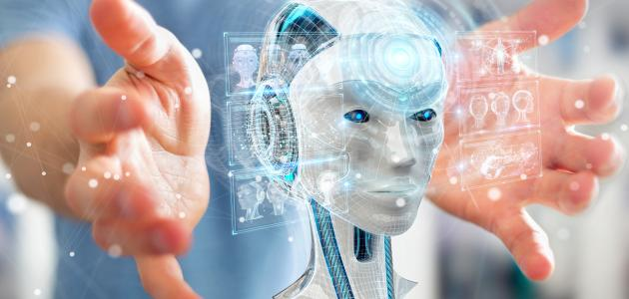This figure demonstrates artificial intelligence:

**Types of artificial intelligence:**

Depending on its capabilities, artificial intelligence can be classified into three different types as follows:

**1- Limited or narrow artificial intelligence**: Weak AI or Narrow AI is a type of artificial intelligence that can perform specific and clear tasks, such as self-driving cars, or even speech or image recognition programs, or chess on smart devices And this type of artificial intelligence is the most common and available today.

**2- General Artificial Intelligence**: is the type that can work with a capacity similar to the human ability in terms of thinking, as it focuses on making the machine able to think and plan on its own and in a similar way to human thinking, but there are no practical examples of This type, for all that exists so far, just research studies need a lot of effort to develop and transform it into reality, and the method of artificial neural network: (Artificial Neural Network) is one of the methods of studying general artificial intelligence, as it is concerned with the production of a system of neural networks for the machine similar to those contained in the body Human.

**3- Superior Artificial Intelligence**: Superior Artificial Intelligence is the type that may exceed the level of human intelligence, and which can do the tasks better than the specialized and knowledgeable man has, and this type has many characteristics that must be included in it; As the ability to learn, plan, automatic communication and make judgments, the concept of super artificial intelligence is considered a hypothetical concept that does not exist in our time.

**Artificial intelligence applications**:

There are many practical applications of artificial intelligence, and the most prominent of these applications are the following:

**1-Games**: Artificial intelligence systems are used in many electronic games. That requires a dimension and strategic thinking, such as poker and chess, for exampl.

**2-Intelligent robots:** Robots do a lot of different actions, as they can do the work that humans do, because of their ability to feel the surrounding factors such as light, heat, sound, or movement, through special sensors, and these robots are able to learn from their past experiences and benefit Of errors.

**3-Interacting with the spoken voice:** Some artificial intelligence systems can be used to listen to speech and understand its meanings, even if it is pronounced with some noise or pronounced in colloquial or street language.

**4-Interacting with the visual system:** Some applications of artificial intelligence can interpret and analyze the images entered into them. Such as facial recognition software, image analysis for positioning, and other applications

**Benefits of artificial intelligence:** It has five benefits:

**1-time saving:**

Artificial intelligence is characterized by saving a lot of companies and jobs from routines that take a lot of time, as it can collect data faster than humans do, which leads to large companies making decisions that rely on information faster, to once again overcome artificial intelligence on humans In a new point.

2**-Eliminate repeat tasks:**

One of the biggest benefits expected of artificial intelligence is that it eliminates the repetition of tasks, which some people fall as a result of the increased workloads, where artificial intelligence is characterized by not repeating a single work twice due to its containing a more complex software system through scheduling and executing works with a high concentration.

**Stay away from the screen:**

-3You can use artificial intelligence to interact with the information as if it is live data, which makes us do not need to look at the computer screen, phone or TV to identify information by simply speaking voice and requesting information, you are answered by answering immediately, and that was applied with the Siri system that is similar to the personal assistant in The business creates ticket, alerts, text and other works.

**4-Deeper specialization:**

Artificial intelligence can search more deeply to find out the requirements of individuals and use it in advertising after years of launch by preserving the taste of customers and specializing in providing the product that users need in an advertising form to attract them, and reaching deeper to the requirements of users through their age groups.

**Software with humans, one team:-5**

With the launch of artificial intelligence significantly, many concepts will be changed. Instead of people using applications and software, software and human beings are at one level, each of them performing their tasks separately as a team within any business, and implementing many basic and important tasks without human intervention in them, which leads Too much business has improved.

**The downsides of artificial intelligence:**

There are five types of downsides of artificial intelligence:

1. **Unemployment**: A person cannot match the machine in terms of efficiency, and thus machines will replace humans in various practical fields, which increases the unemployment rat.
2. **Data loss:** Despite the tremendous memory that such machines may have, there will be no correlation between this information when it is stored and retrieved as humans do, and some damage to the machine can lead to the loss of all data stored on it
3. **There is no place for emotions:** all human perceptions of conscience, mercy, and collective spirit will disappear, meaning that machines can perform many tasks without there being links with humans, and thus artificial intelligence cannot replace human relationships.
4. **High cost:** Working in this field requires a lot of money both in the machinery manufacturing processes, programming and repair.
5. **Wrong use:** As many inventions invented by scientists for important purposes, but when they fell into the wrong hands, they were exploited for wars, and the exploitation of artificial intelligence for unscientific purposes and not serving society posed a real threat.

**The Implementation Code:**

1. **The Main Page:**

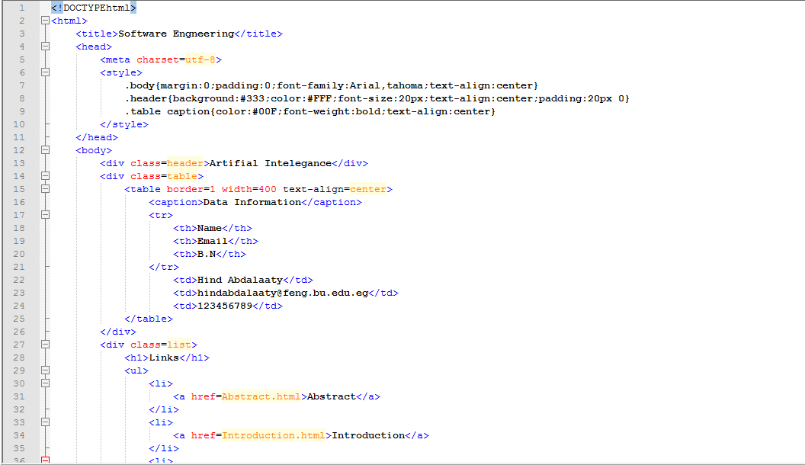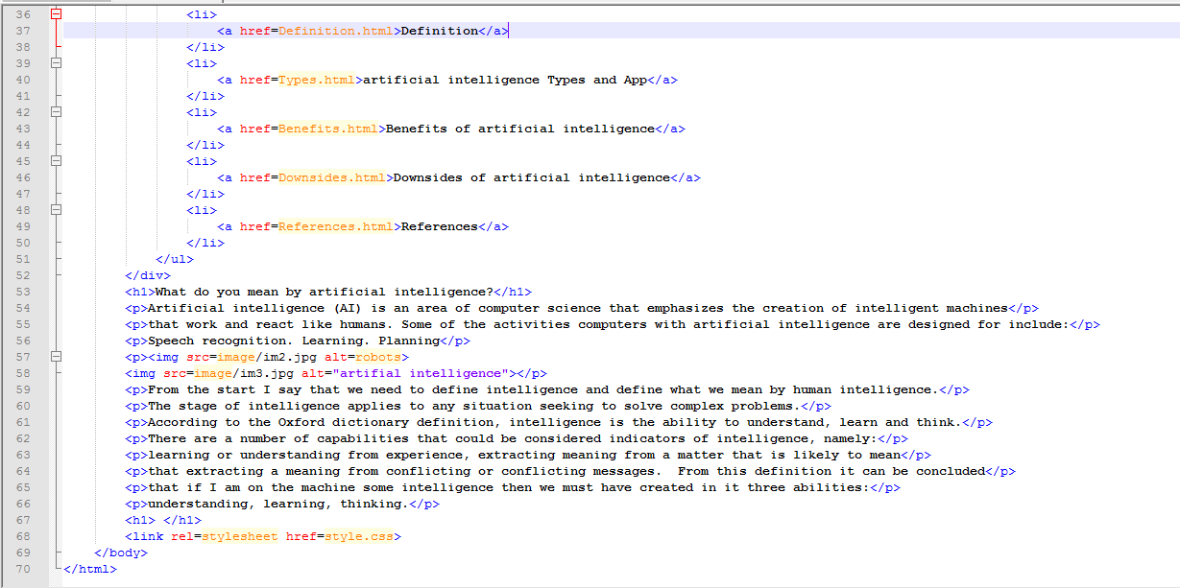

1. **Introduction**

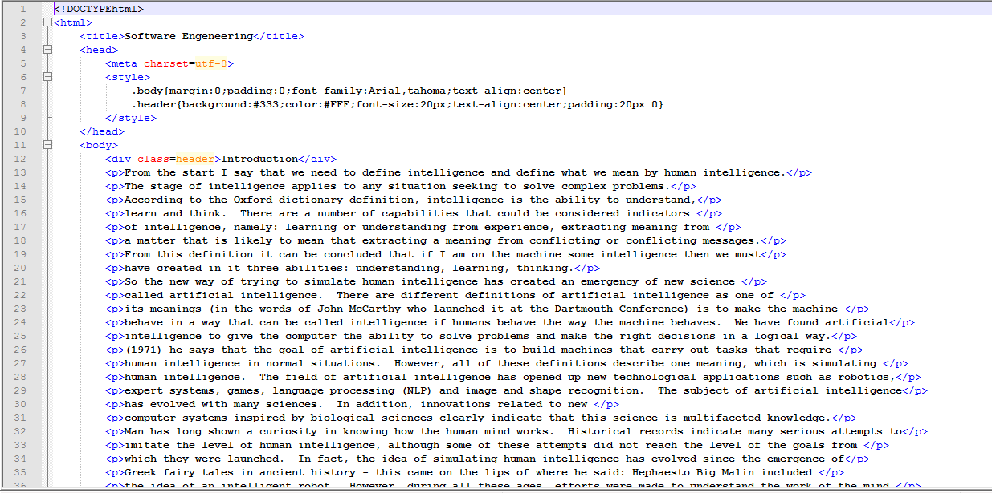

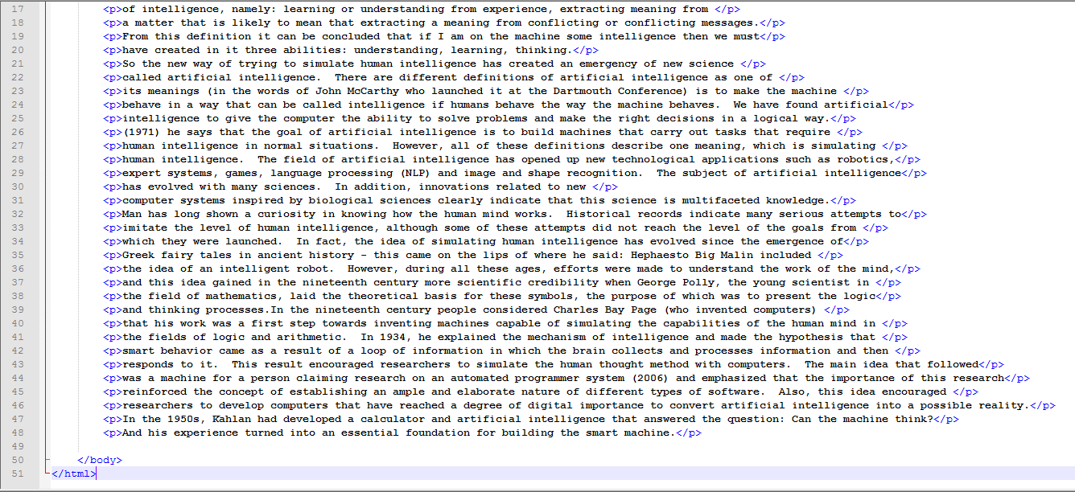

1. **Abstract**

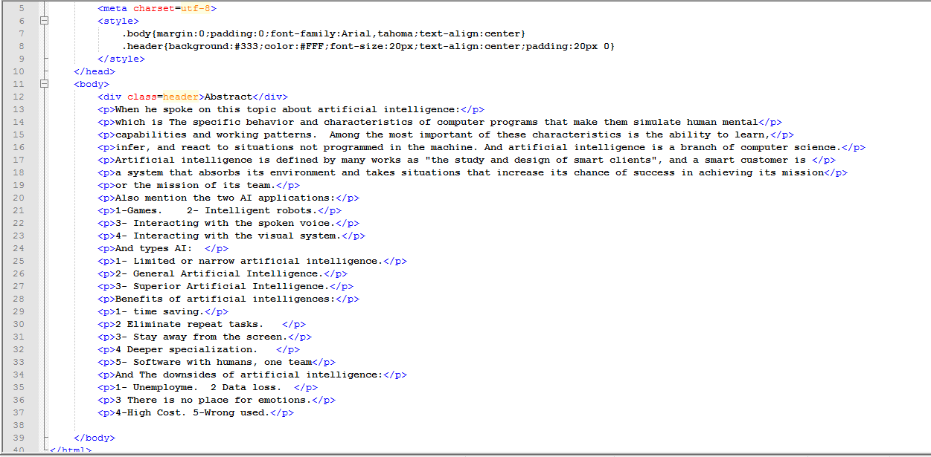

1. **Definition**

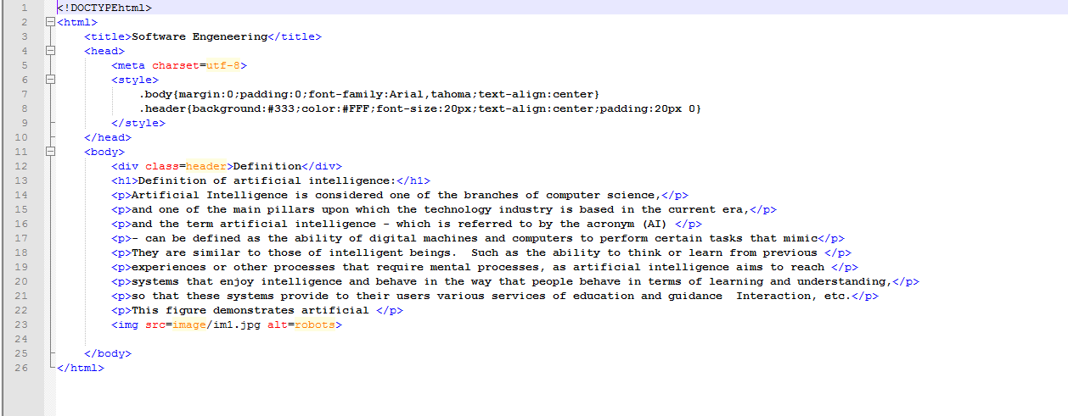

1. **Types**

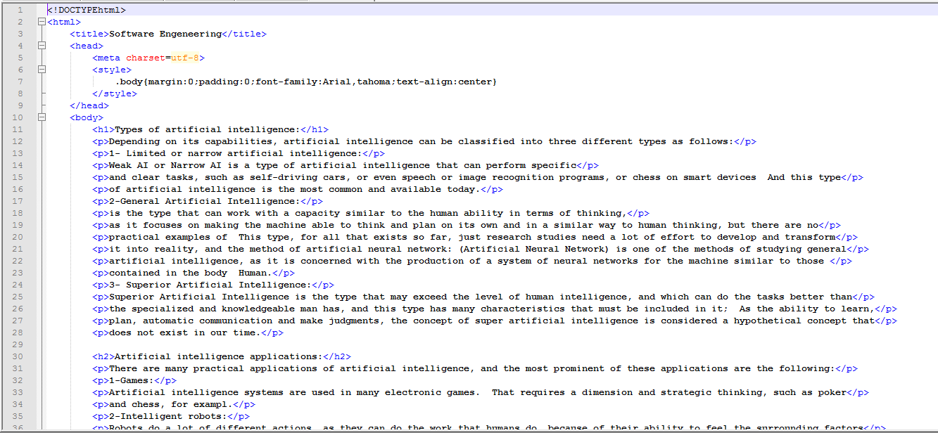

1. **Benefits**

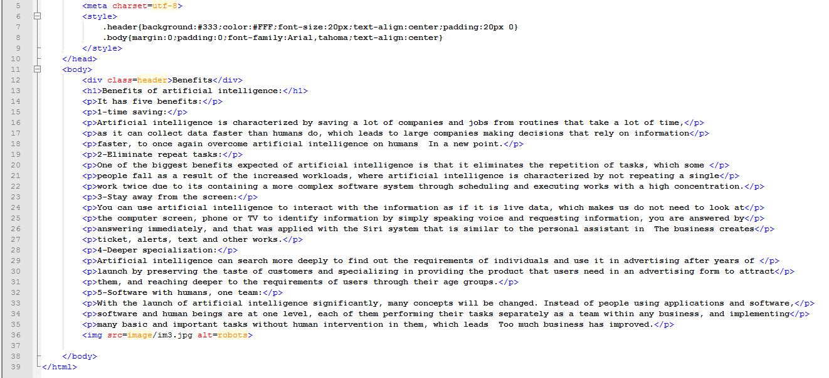

1. **Downsides**

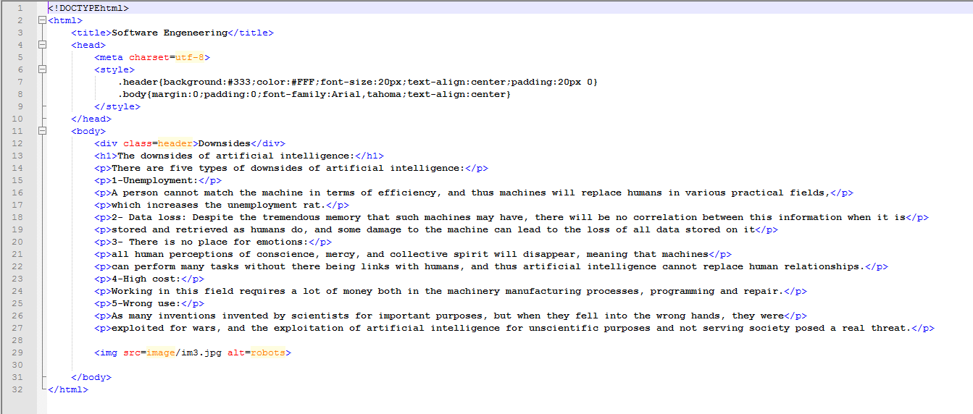

1. **References**

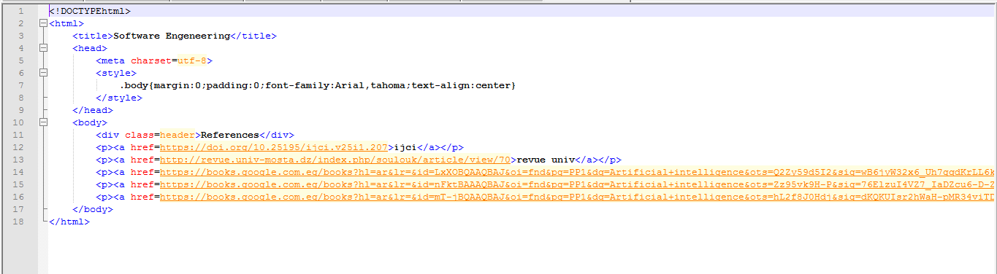

**The Screenshot for websites:**

1. **The Main Page**

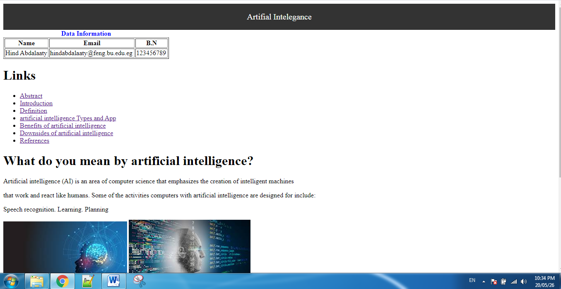

1. **Abstract**

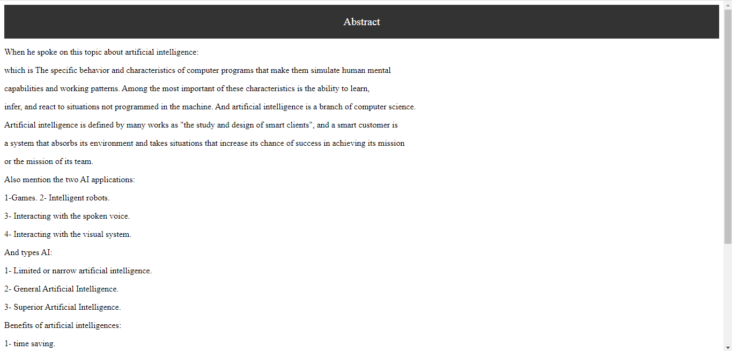

1. **Introduction**

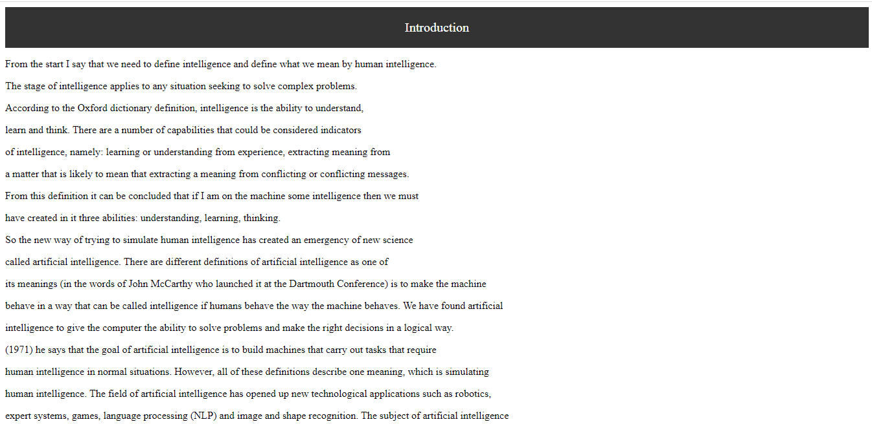

1. **Types**

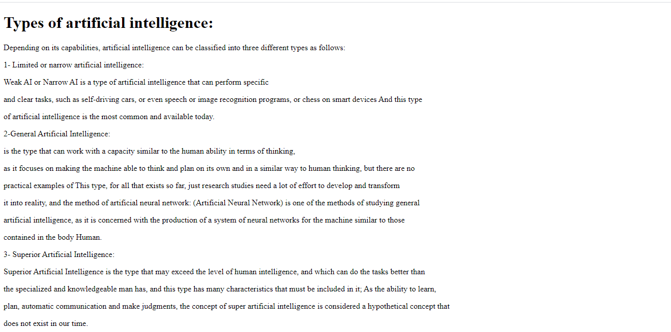

1. **Referance**

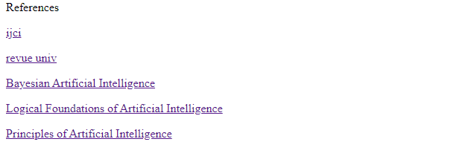

**References**

(1)<https://doi.org/10.25195/ijci.v25i1.207>

(2)<http://revue.univ-mosta.dz/index.php/soulouk/article/view/70>

(3)<https://books.google.com.eg/books?hl=ar&lr=&id=LxXOBQAAQBAJ&oi=fnd&pg=PP1&dq=Artificial+intelligence&ots=Q2Zy59d5I2&sig=wB6jyW32x6_Uh7gqdKrLL6kj_1M&redir_esc=y> (4)<https://books.google.com.eg/books?hl=ar&lr=&id=nFktBAAAQBAJ&oi=fnd&pg=PP1&dq=Artificial+intelligence&ots=Zz95vk9H-P&sig=76ElzuI4VZ7_IaDZcu6-D-Z7FMw&redir_esc=y>

(5)<https://books.google.com.eg/books?hl=ar&lr=&id=mT-jBQAAQBAJ&oi=fnd&pg=PP1&dq=Artificial+intelligence&ots=hL2f8J0Hdj&sig=dKQKUIsr2hWaH-pMR34viTDnk9A&redir_esc=y>